Appendix U. System Screenshots
The screens below are captures of the running prototype operating on the seeded demonstration dataset. Where a screen fits on a page it is reproduced in full, including the portion that requires scrolling in the browser. Where a screen is too long to reproduce at a legible size — the recommendations and work queue screens in particular run to several screen heights — the visible window is shown instead and the caption says so. Screens are captured under an administrator account unless the caption names another role.

Appendix U.1. Login screen
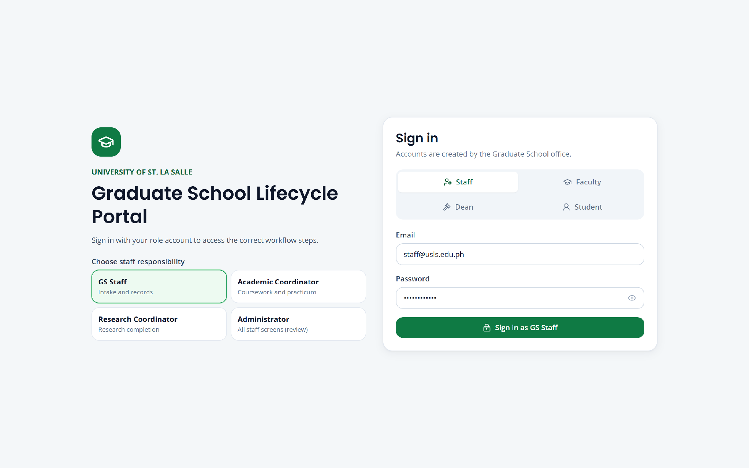

Figure U.1. Login screen (full screen)

Appendix U.2. Dashboard — Graduate School overview
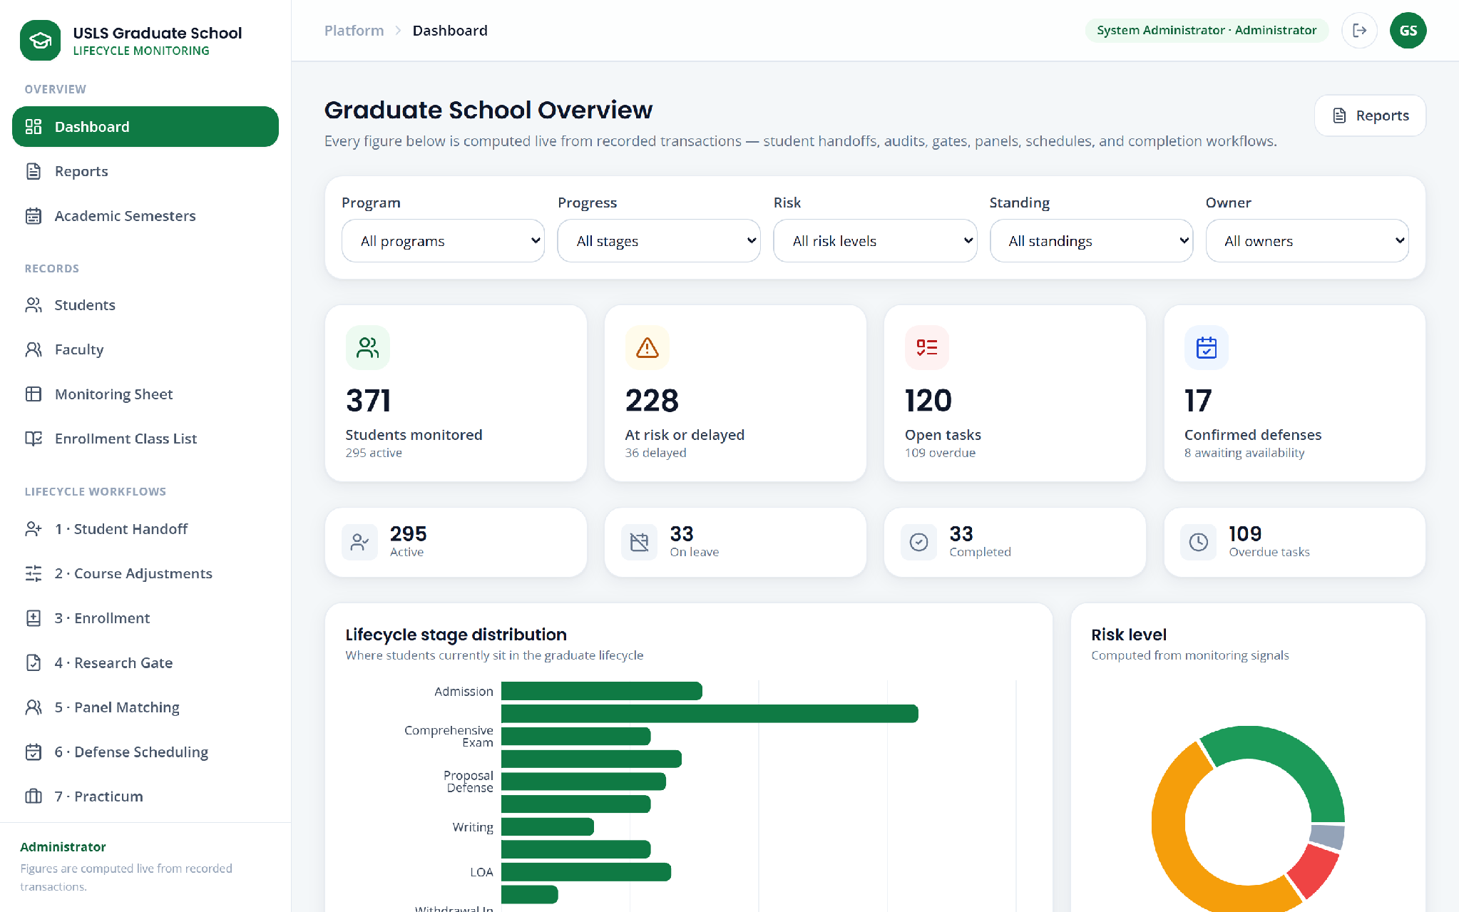

Figure U.2. Dashboard — Graduate School overview (visible window; the screen continues below)

Appendix U.3. Reports
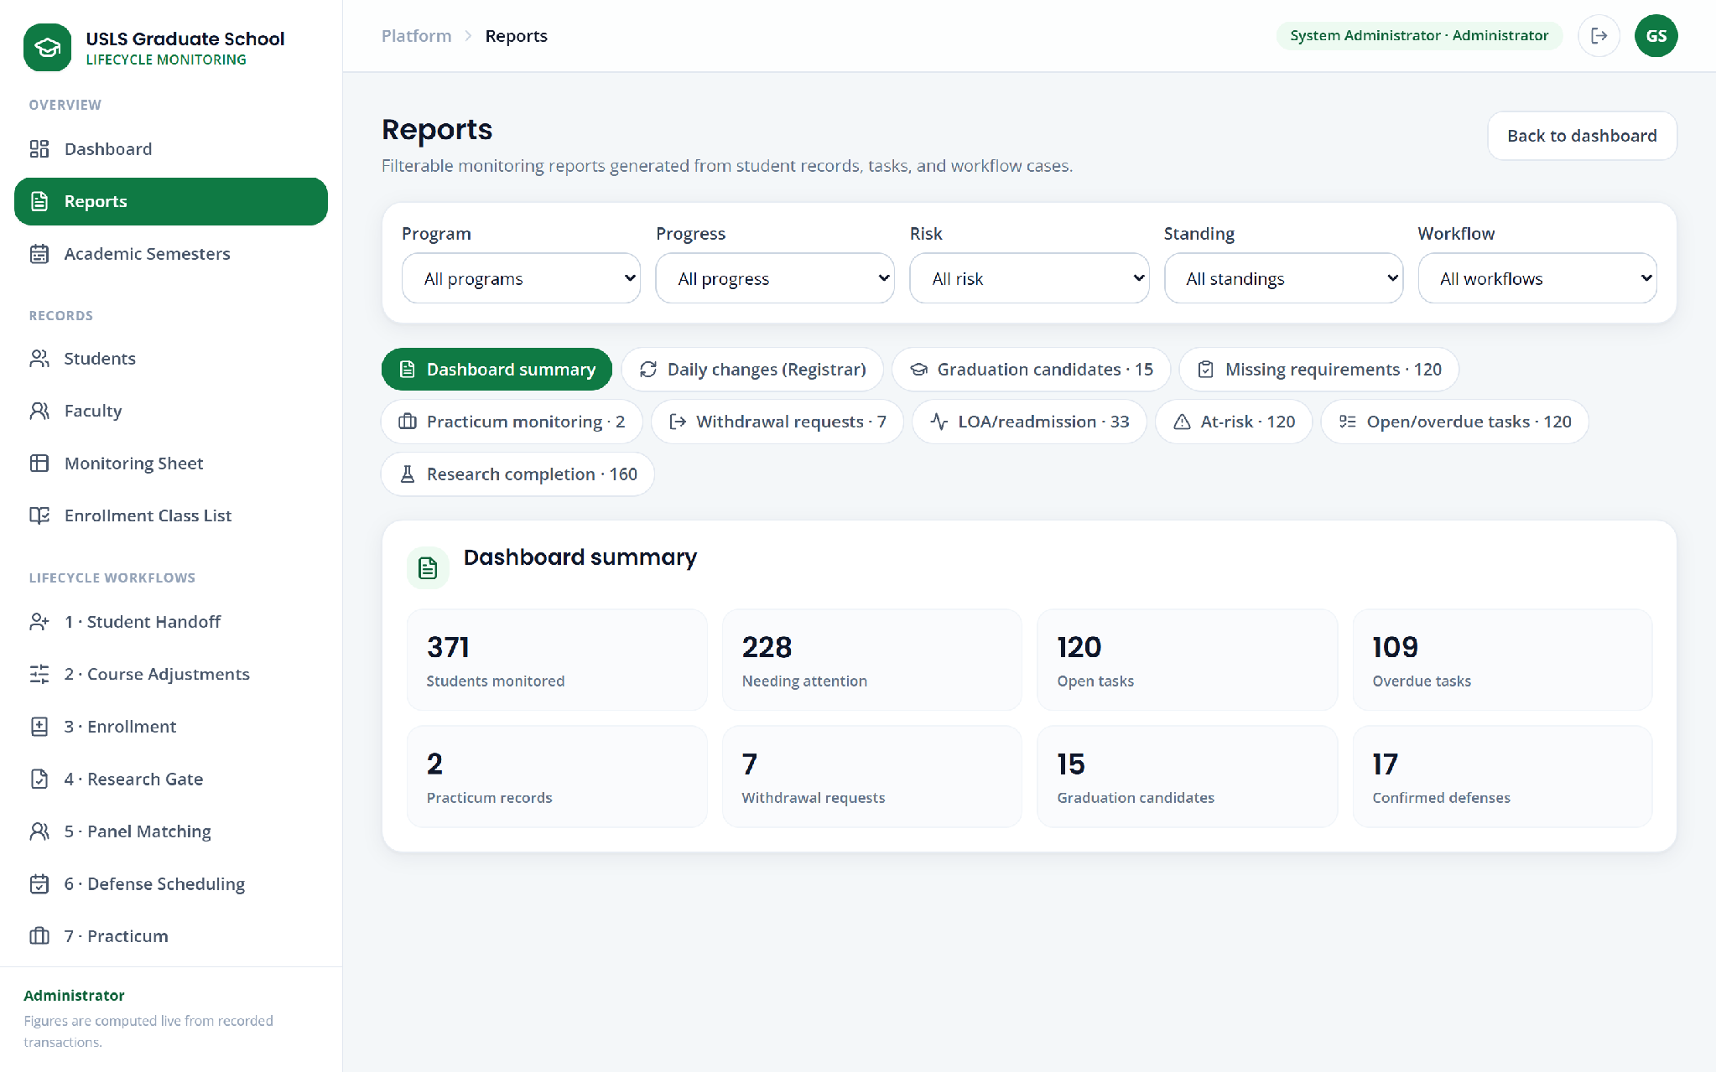

Figure U.3. Reports (full screen)

Appendix U.4. Academic semesters
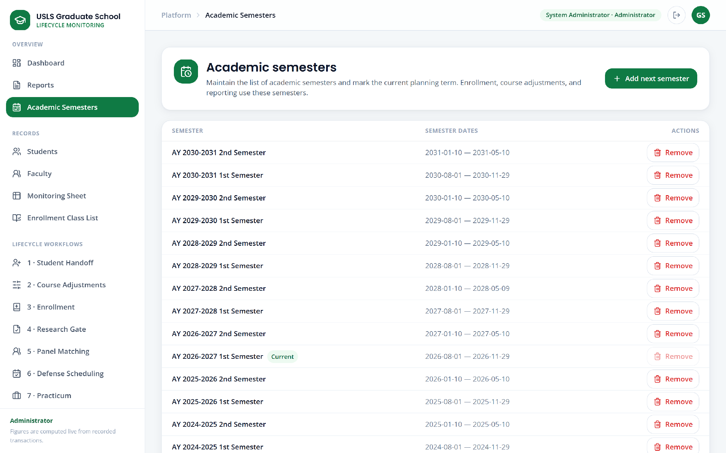

Figure U.4. Academic semesters (full screen)

Appendix U.5. Students
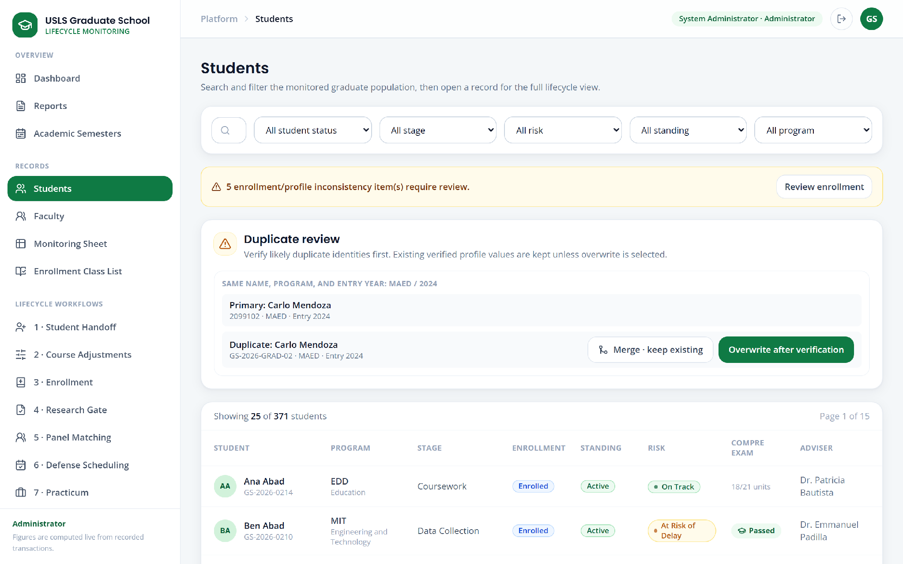

Figure U.5. Students (visible window; the screen continues below)

Appendix U.6. Faculty records
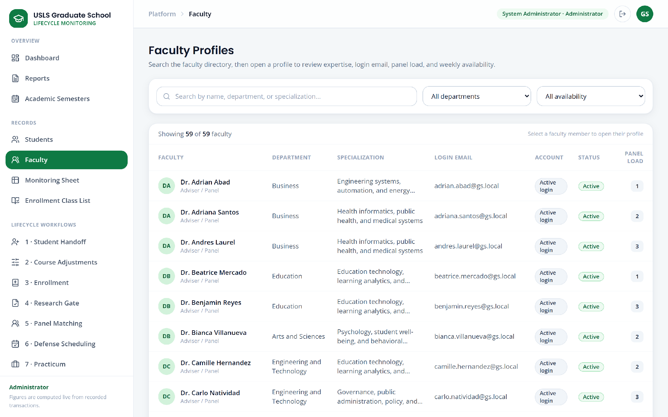

Figure U.6. Faculty records (visible window; the screen continues below)

Appendix U.7. Monitoring sheet
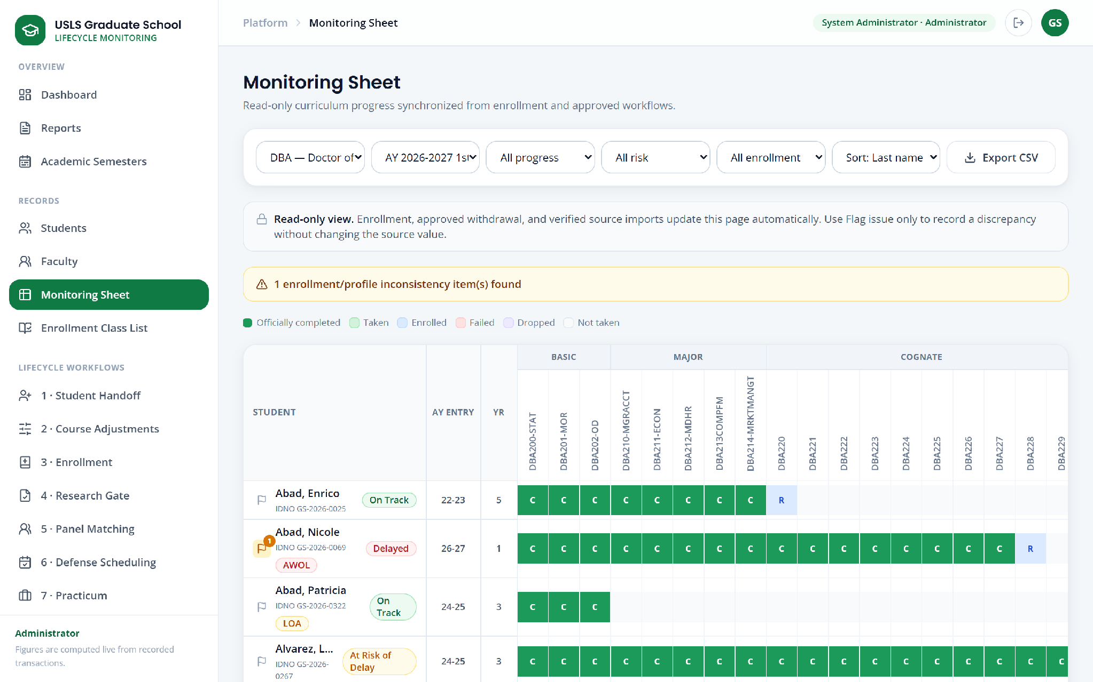

Figure U.7. Monitoring sheet (full screen)

Appendix U.8. Enrollment class list
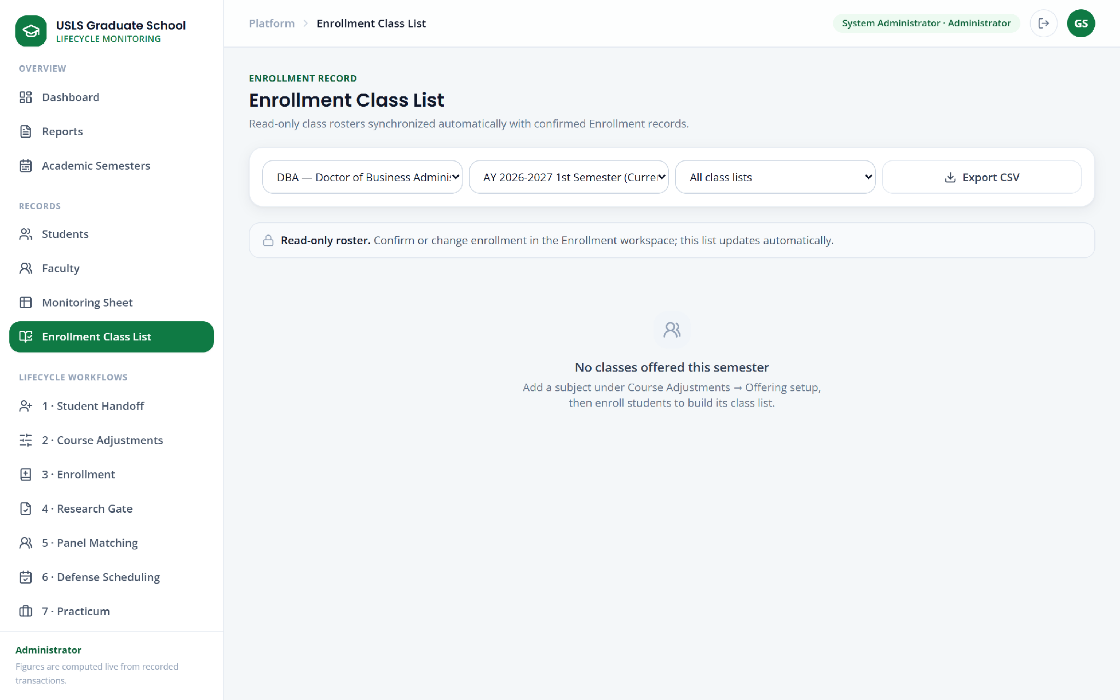

Figure U.8. Enrollment class list (full screen)

Appendix U.9. Student handoff
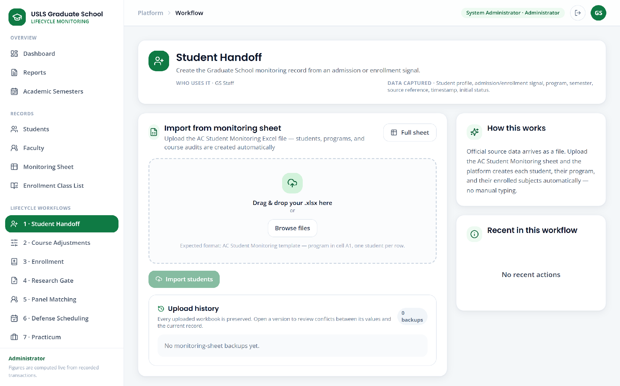

Figure U.9. Student handoff (full screen)

Appendix U.10. Course adjustments and subject needs
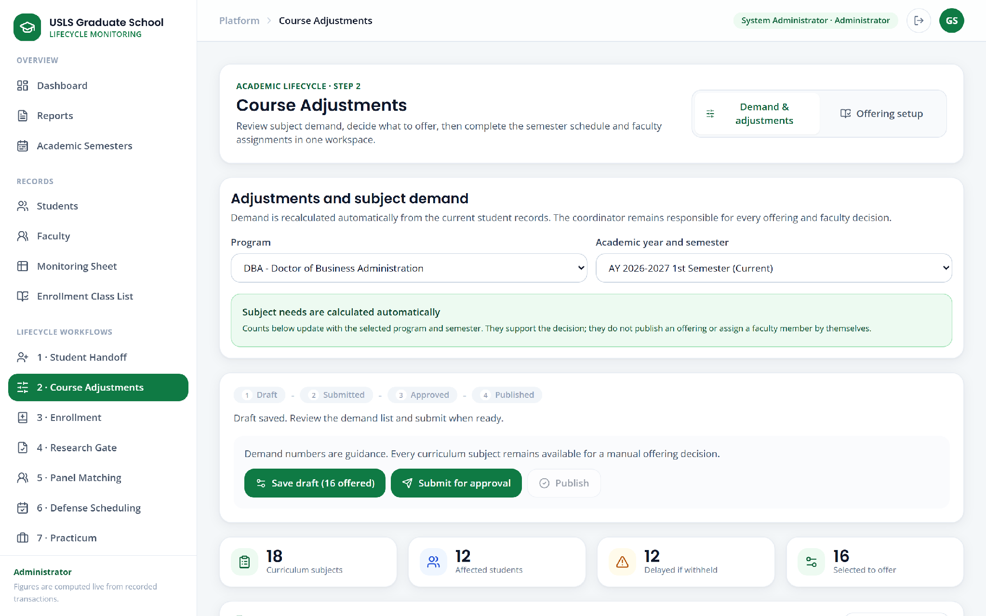

Figure U.10. Course adjustments and subject needs (visible window; the screen continues below)

Appendix U.11. Course offering setup
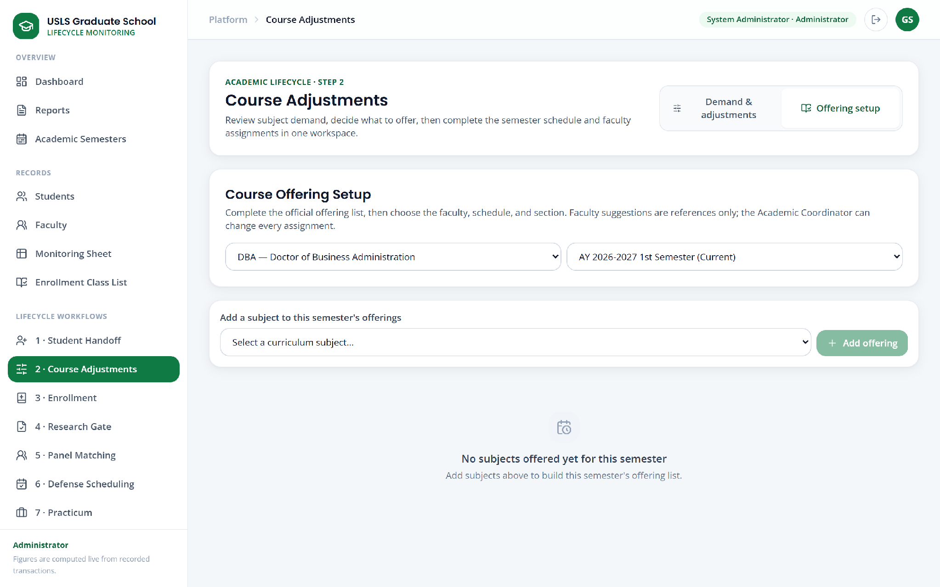

Figure U.11. Course offering setup (full screen)

Appendix U.12. Enrollment
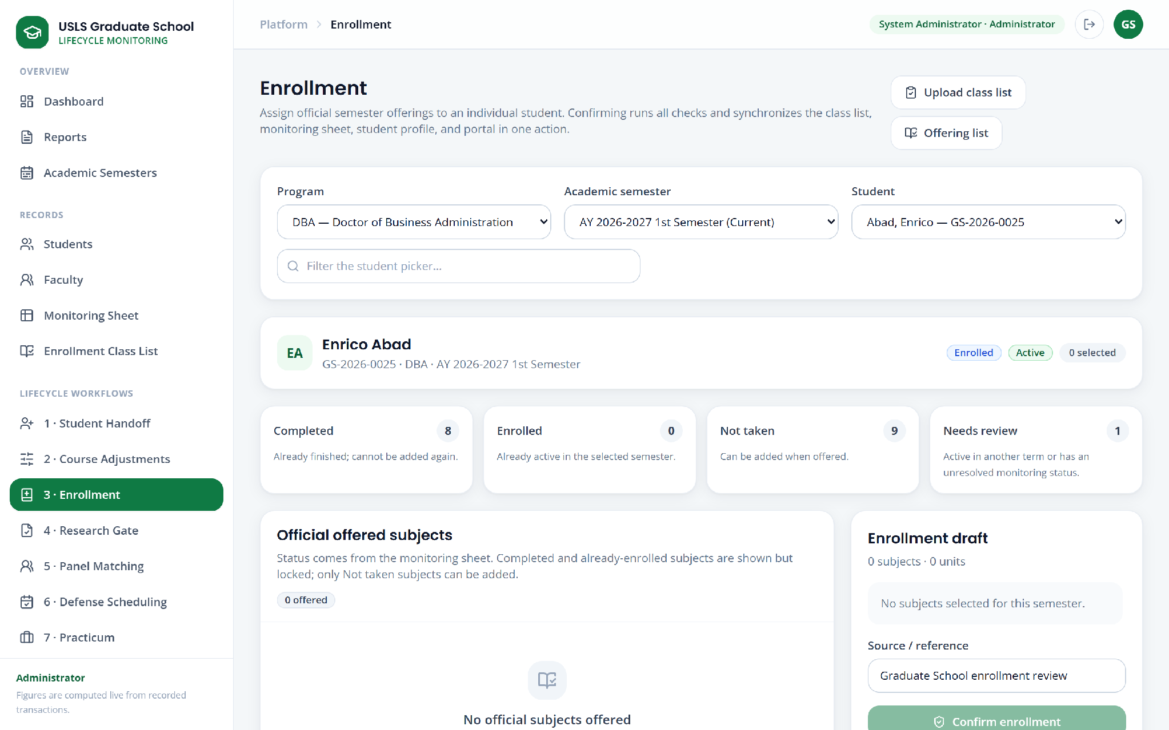

Figure U.12. Enrollment (full screen)

Appendix U.13. Research gate
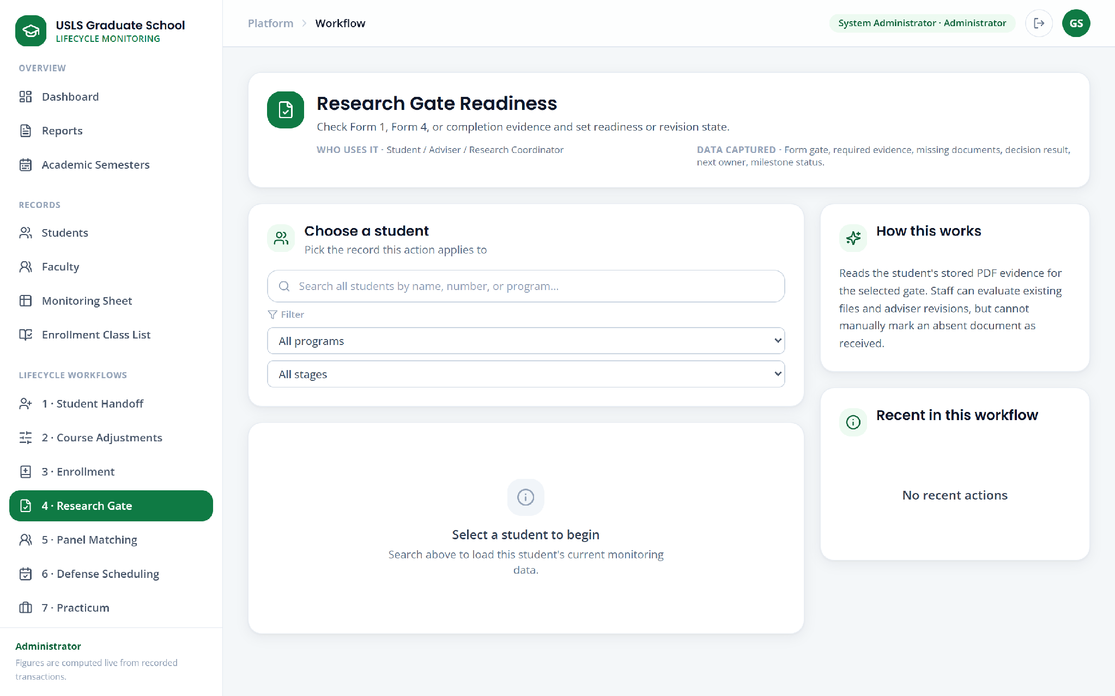

Figure U.13. Research gate (full screen)

Appendix U.14. Panel matching
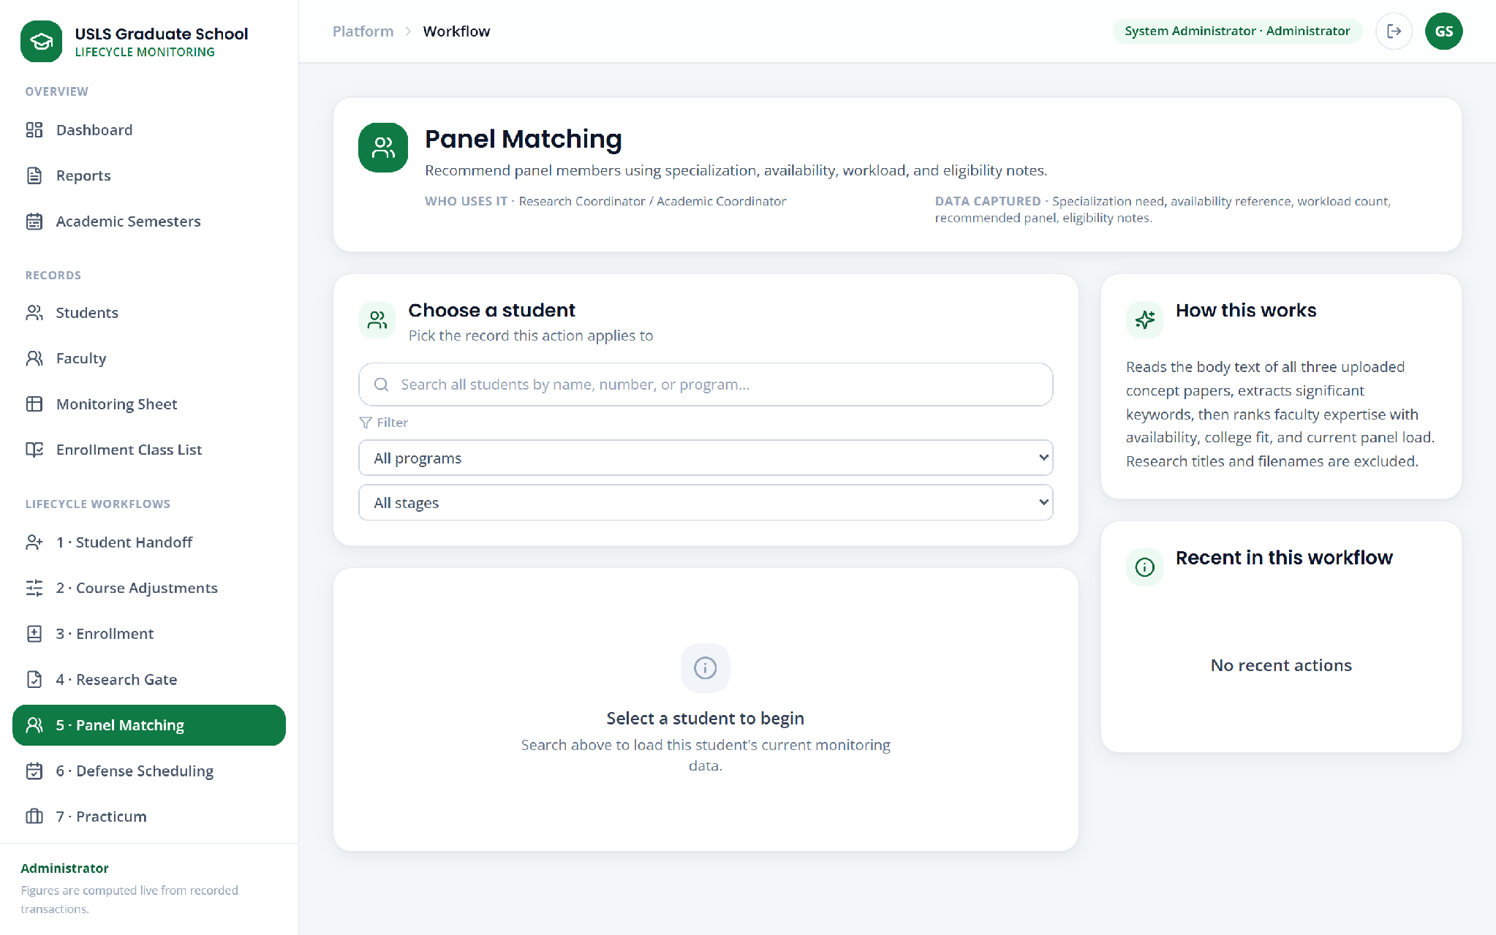

Figure U.14. Panel matching (full screen)

Appendix U.15. Defense scheduling
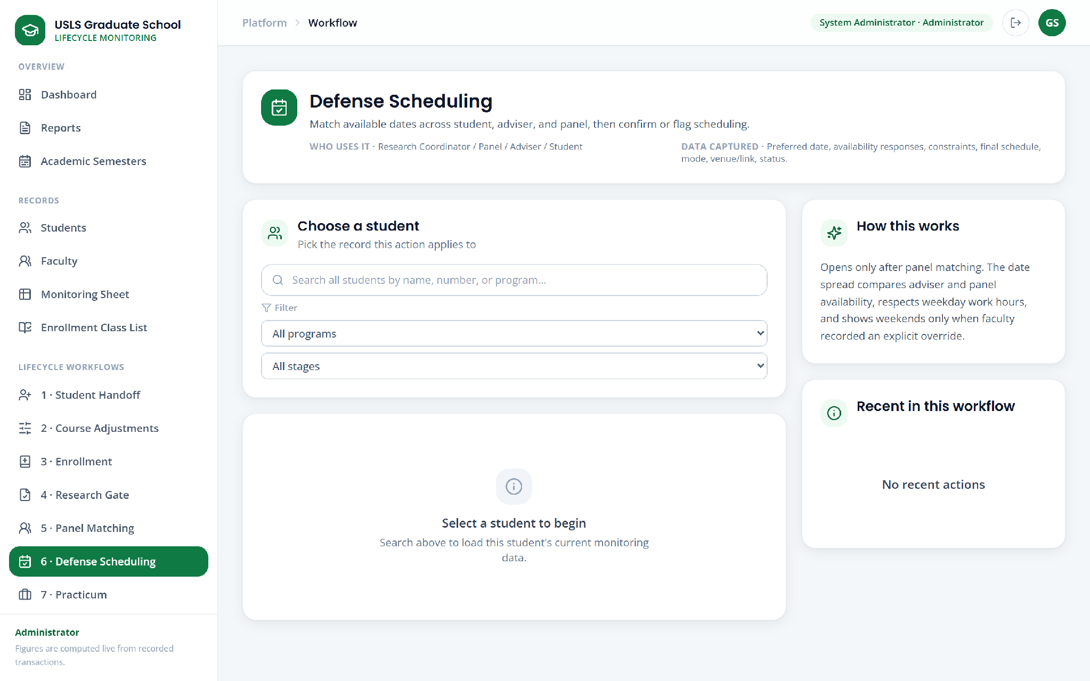

Figure U.15. Defense scheduling (full screen)

Appendix U.16. Practicum monitoring
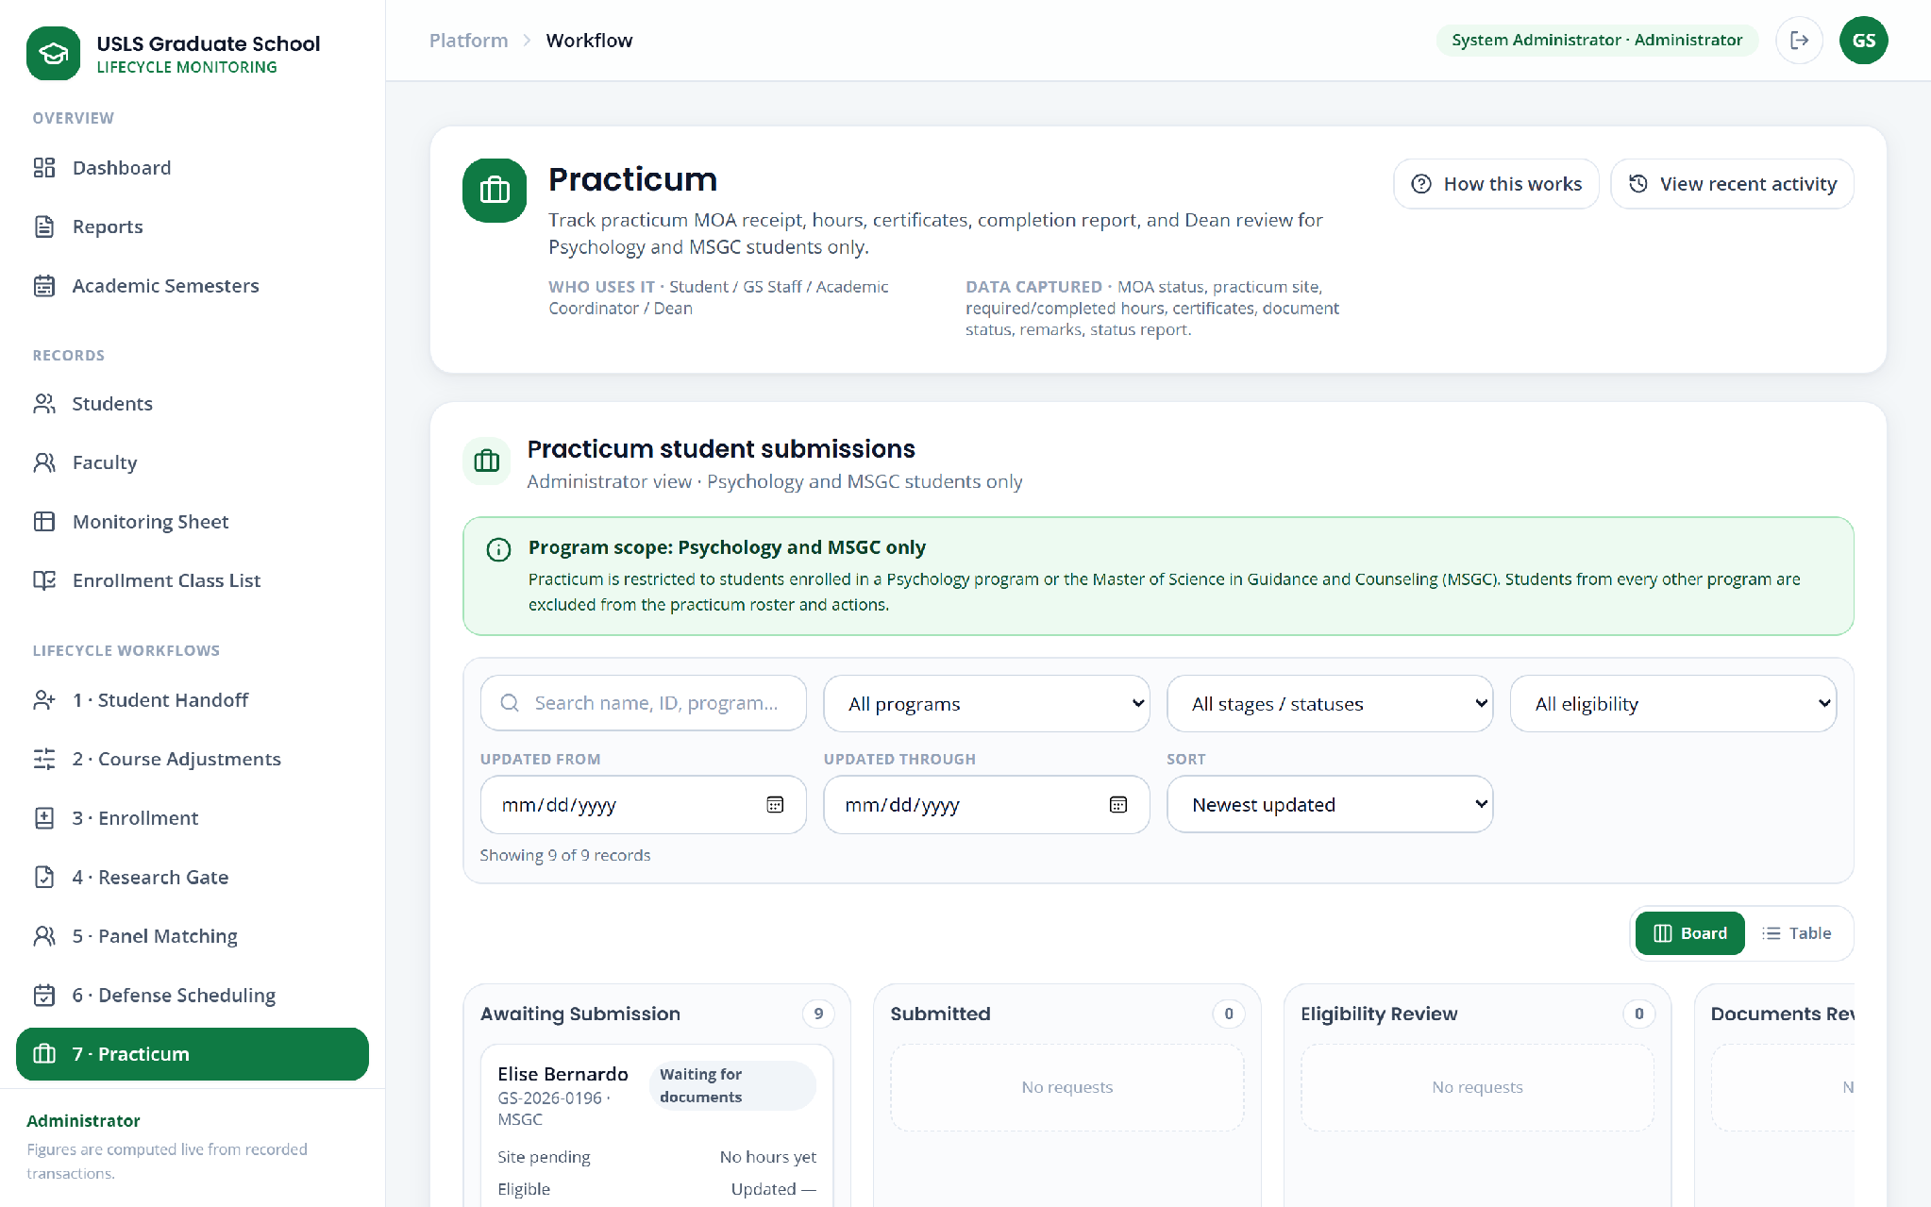

Figure U.16. Practicum monitoring (visible window; the screen continues below)

Appendix U.17. Graduation endorsement
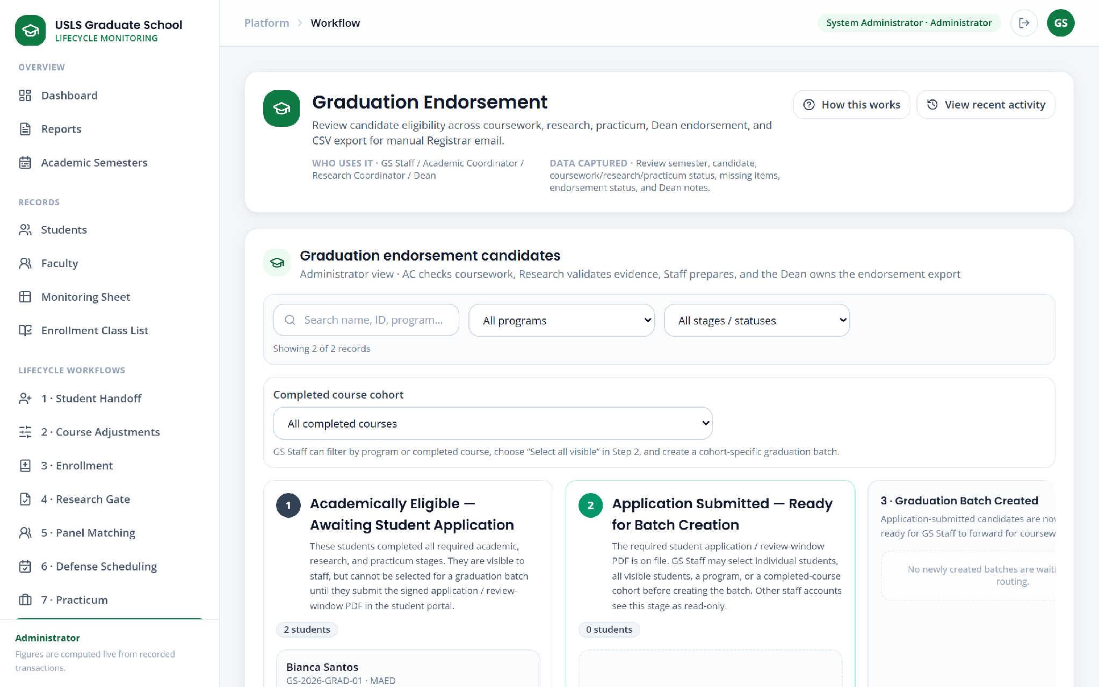

Figure U.17. Graduation endorsement (full screen)

Appendix U.18. Leave of absence
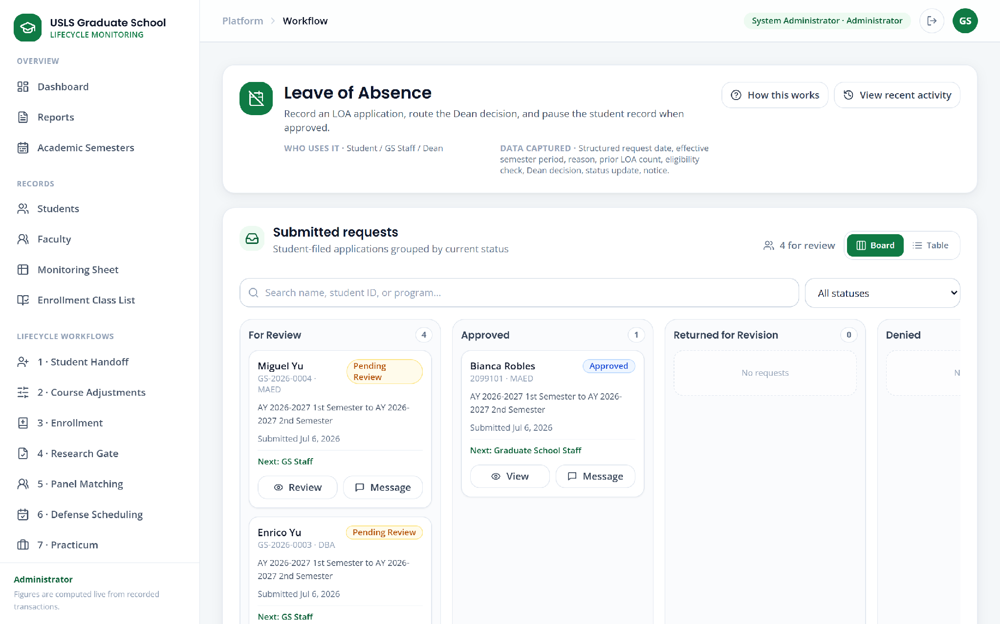

Figure U.18. Leave of absence (full screen)

Appendix U.19. Readmission
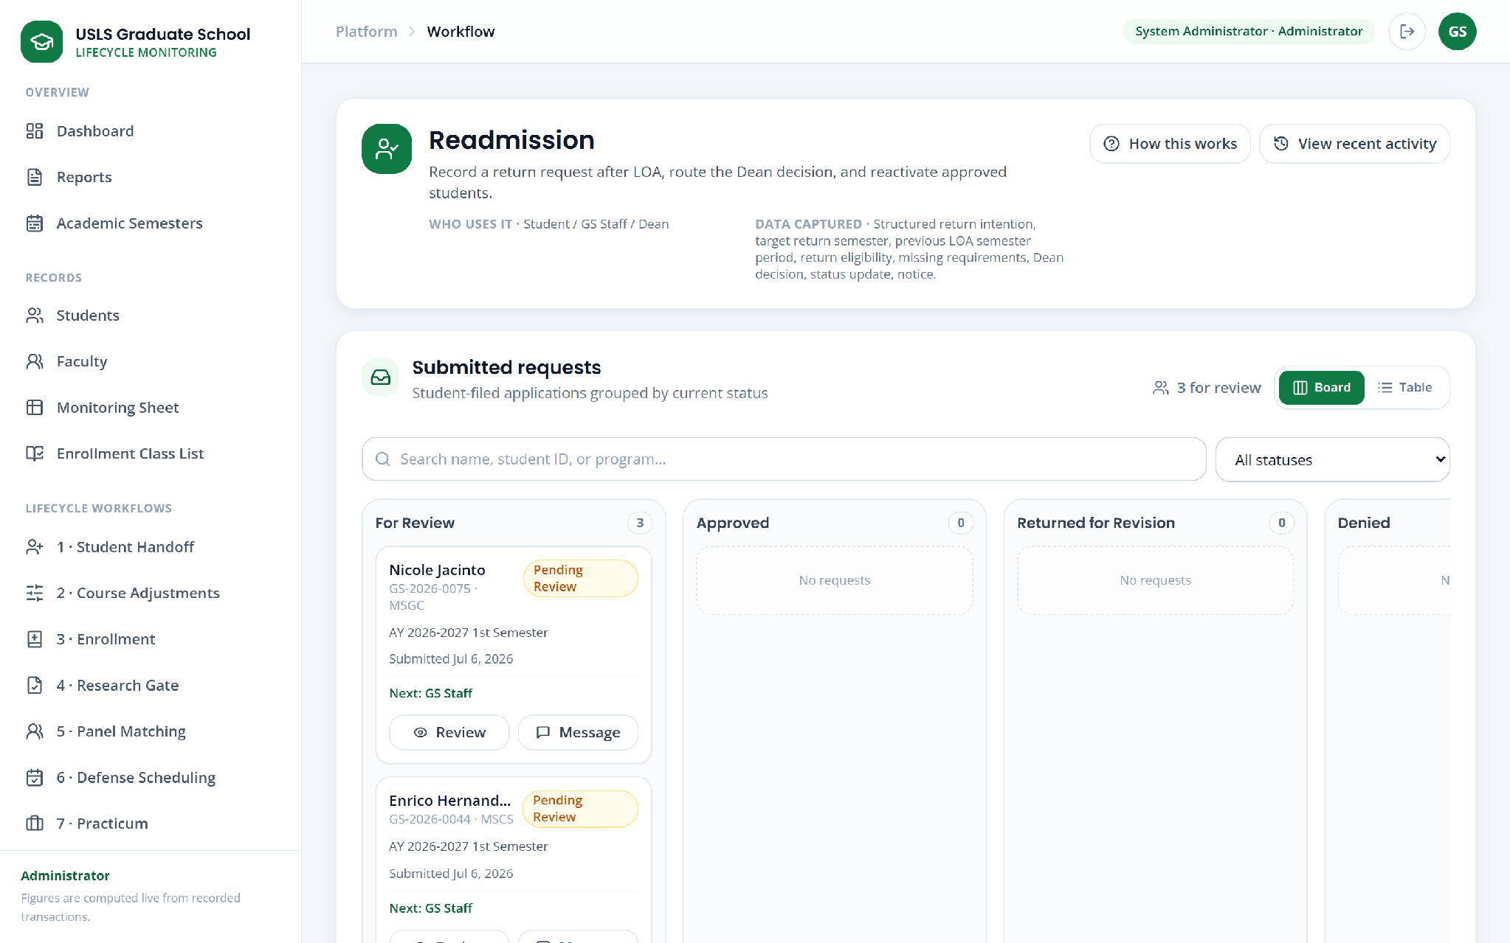

Figure U.19. Readmission (full screen)

Appendix U.20. AWOL and residency
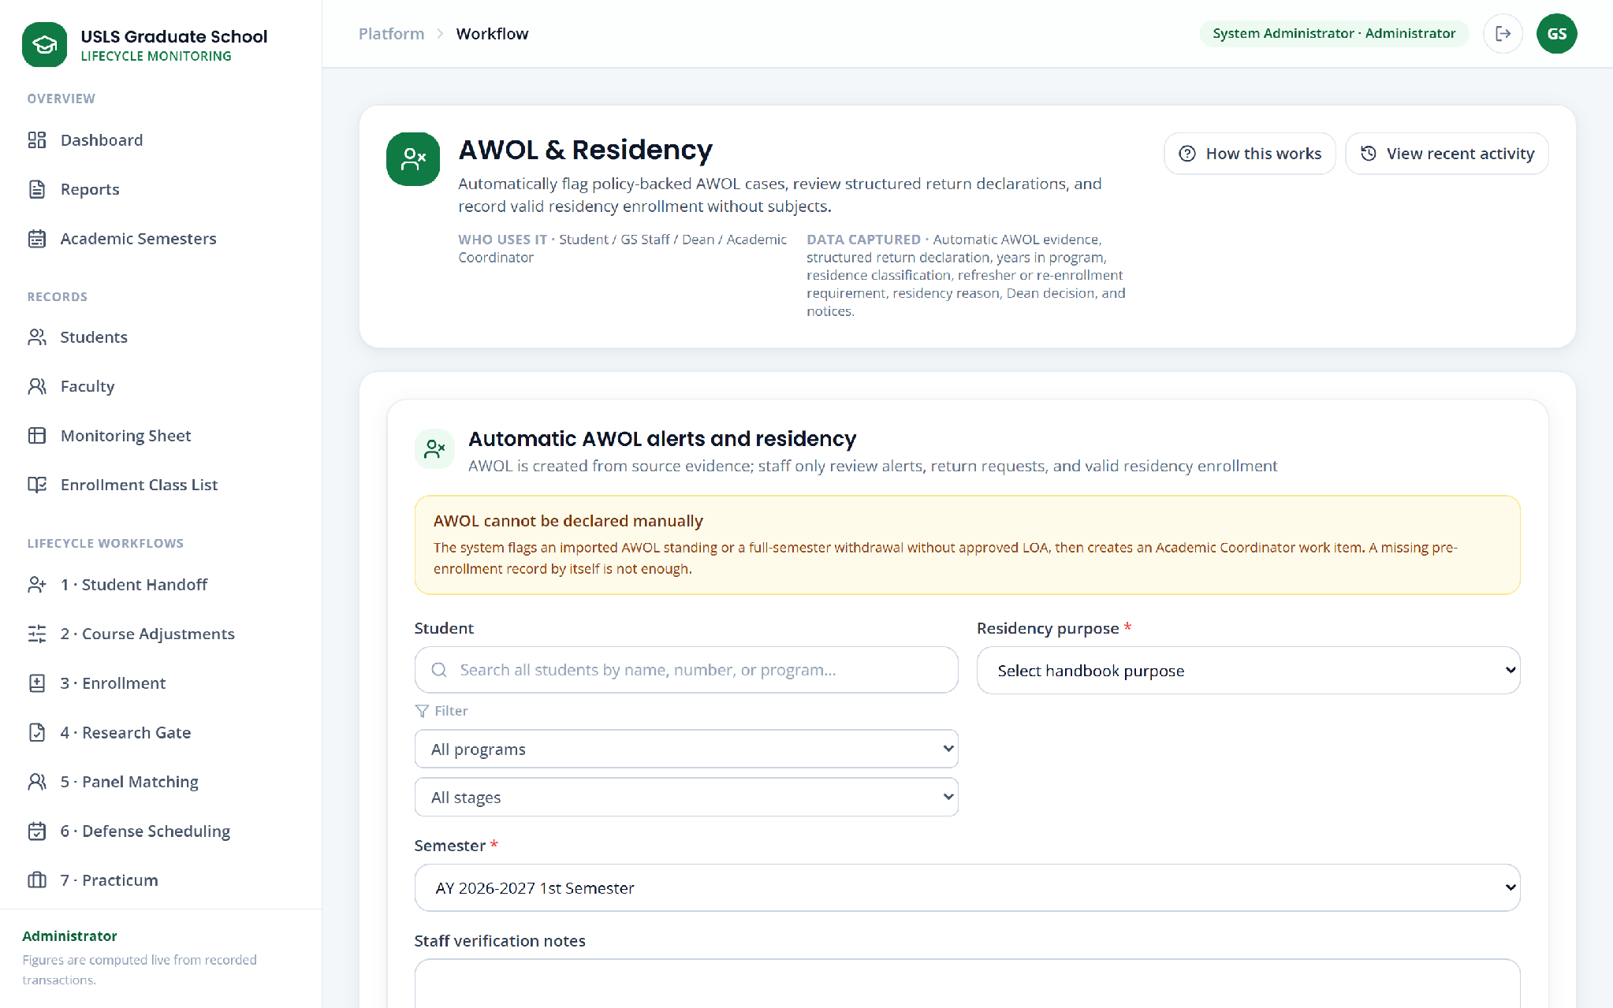

Figure U.20. AWOL and residency (visible window; the screen continues below)

Appendix U.21. Subject withdrawal requests
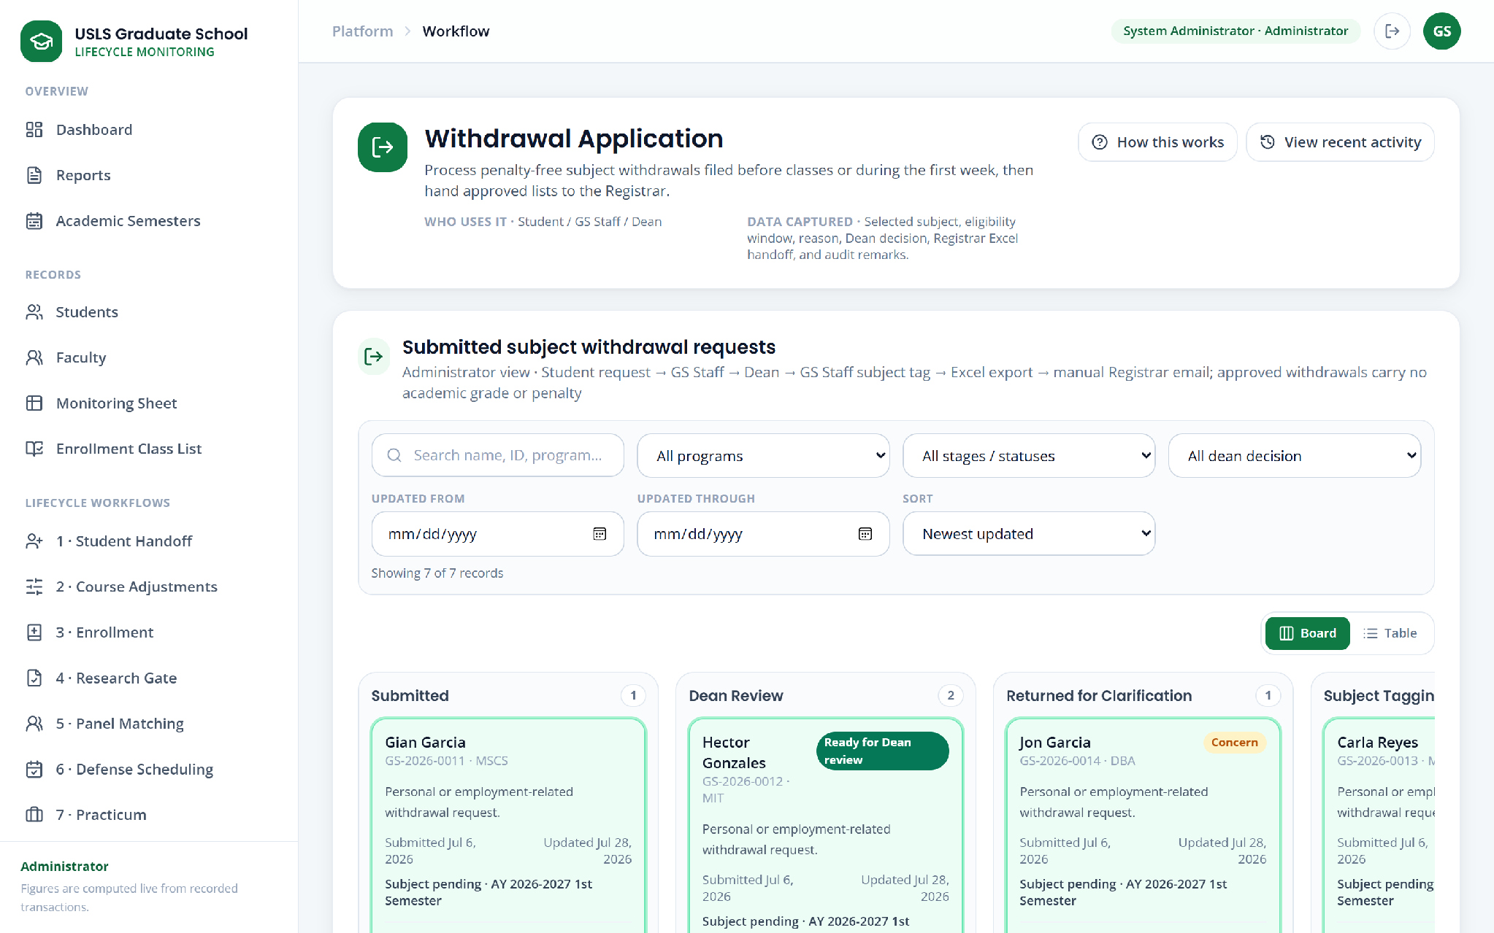

Figure U.21. Subject withdrawal requests (full screen)

Appendix U.22. Work queue
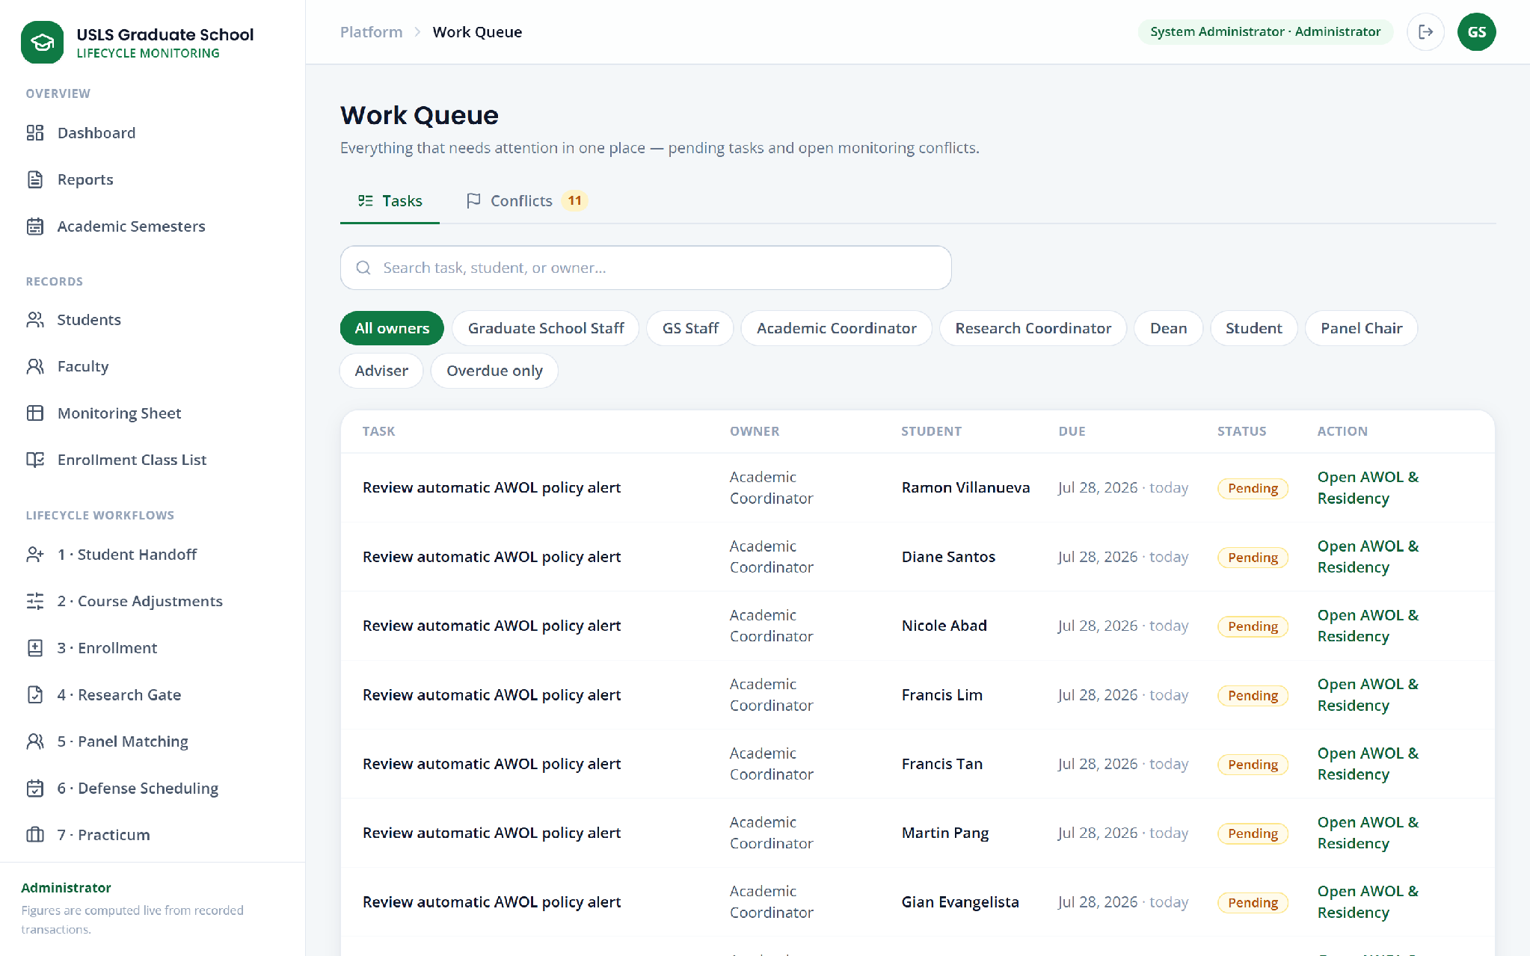

Figure U.22. Work queue (visible window; the screen continues below)

Appendix U.23. Activity log
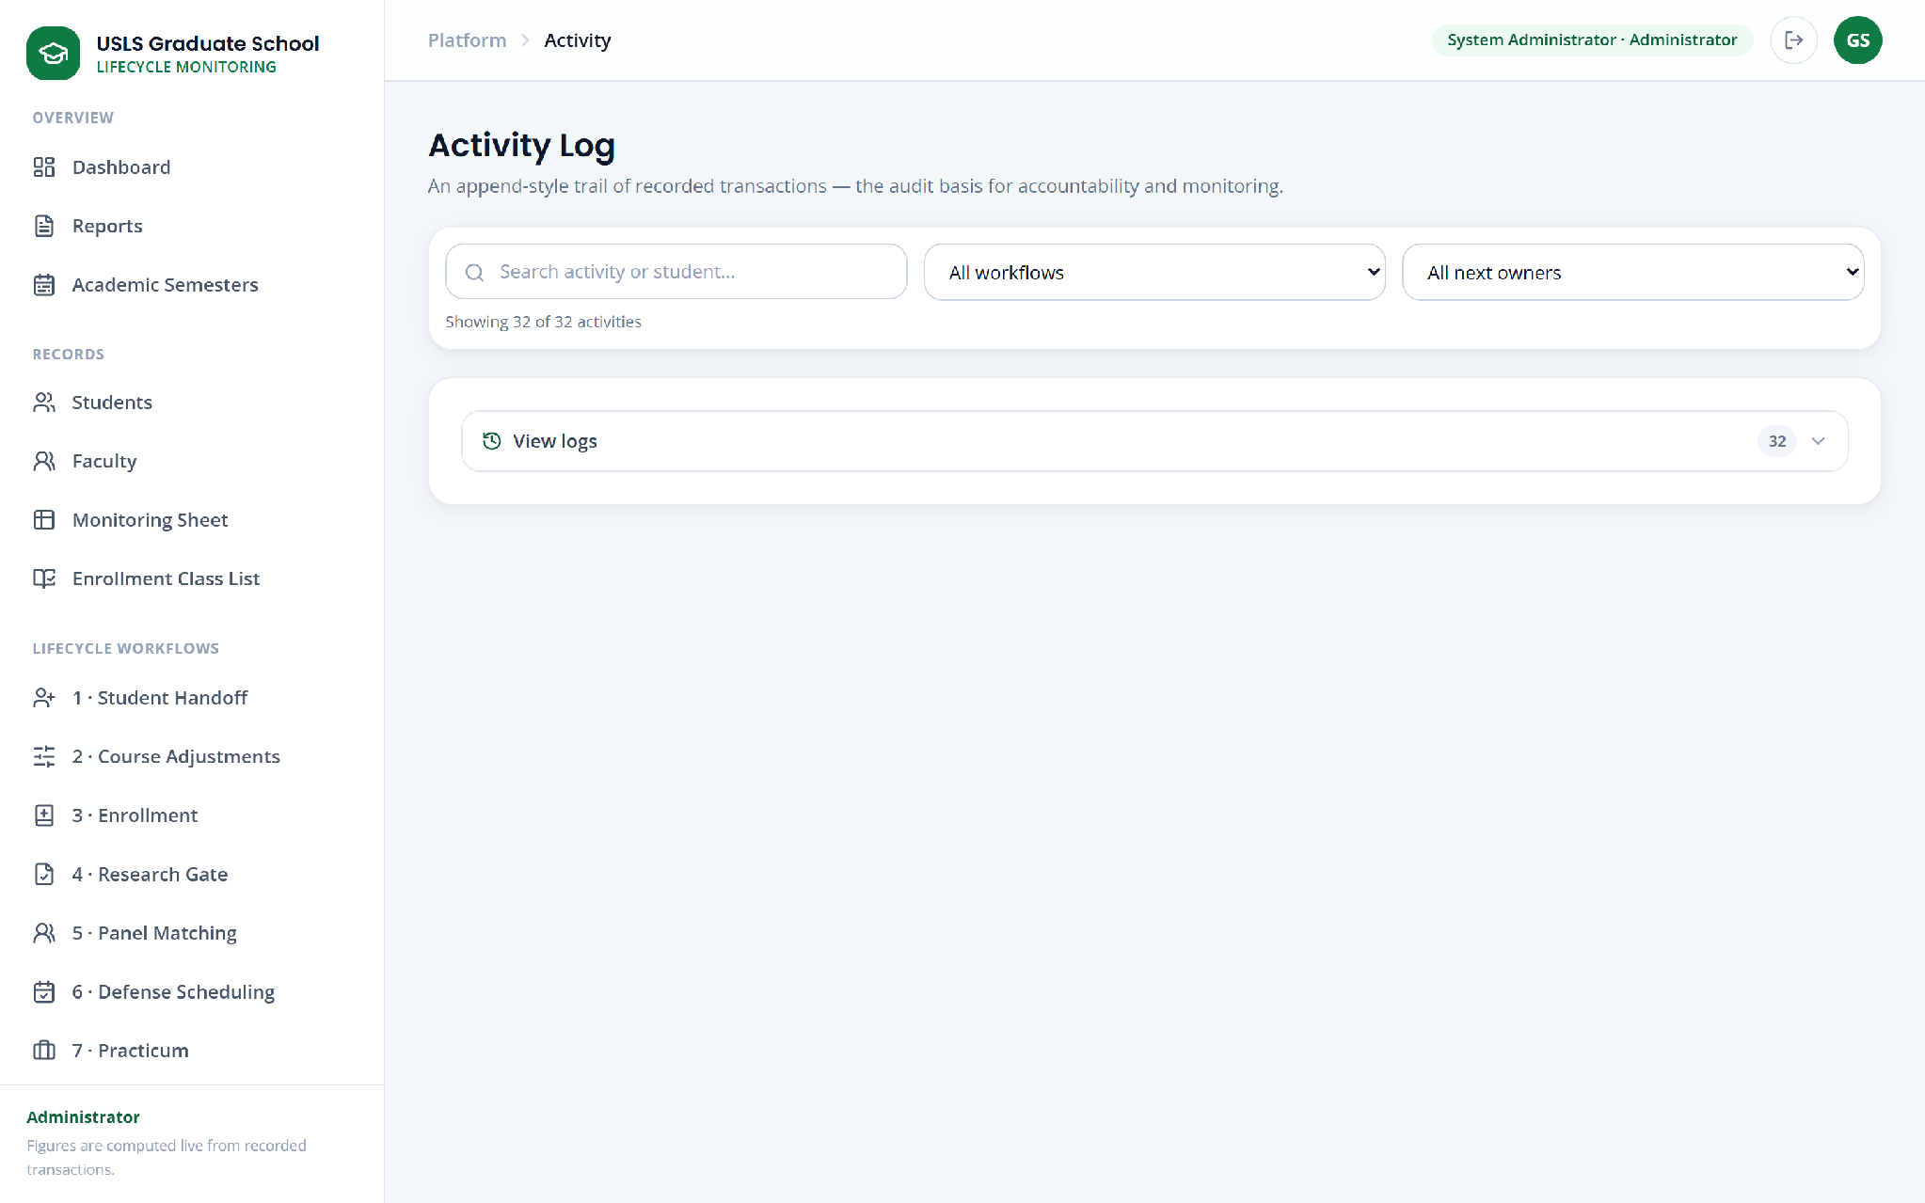

Figure U.23. Activity log (full screen)

Appendix U.24. Recommendations
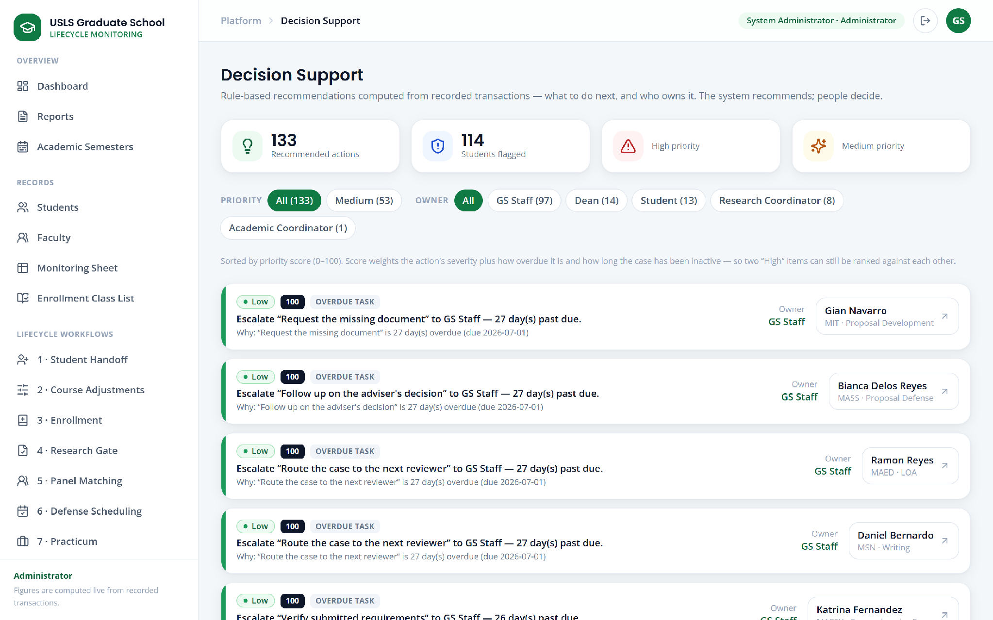

Figure U.24. Recommendations (visible window; the screen continues below)

Appendix U.25. Policy assistant
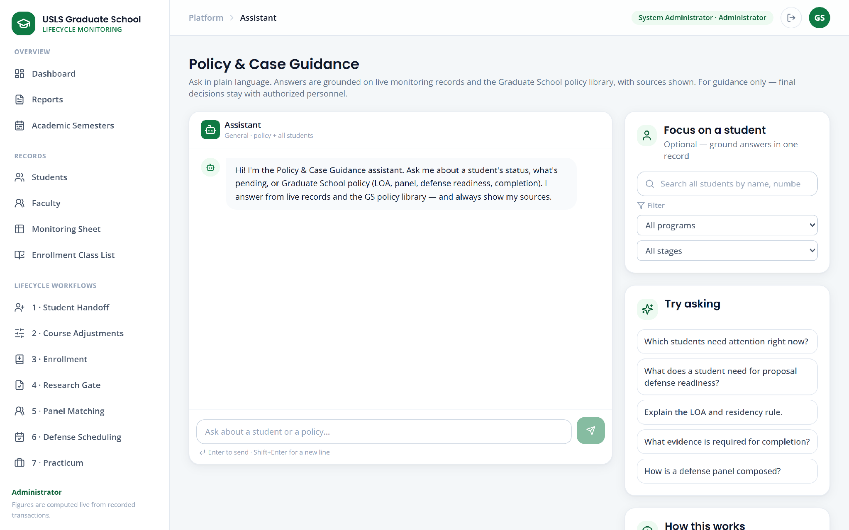

Figure U.25. Policy assistant (full screen)

Appendix U.26. Form 1 endorsements


Figure U.26. Form 1 endorsements (visible window; the screen continues below)

Appendix U.27. Student detail
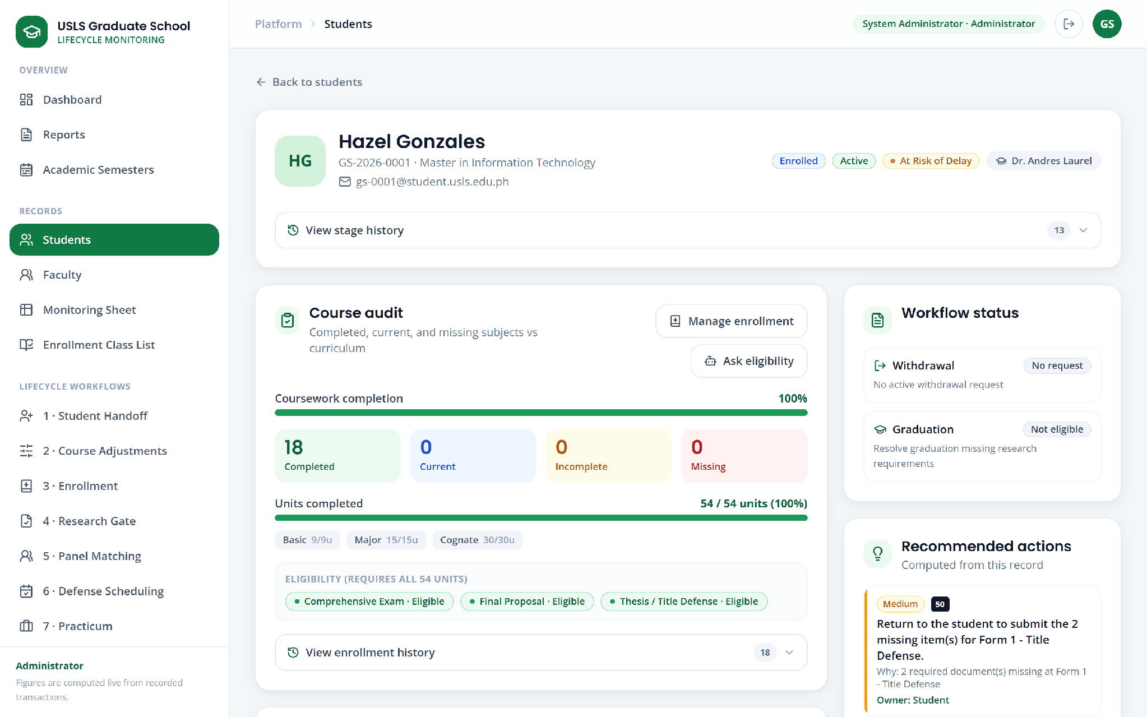

Figure U.27. Student detail (full screen)

Appendix U.28. Dean approvals queue
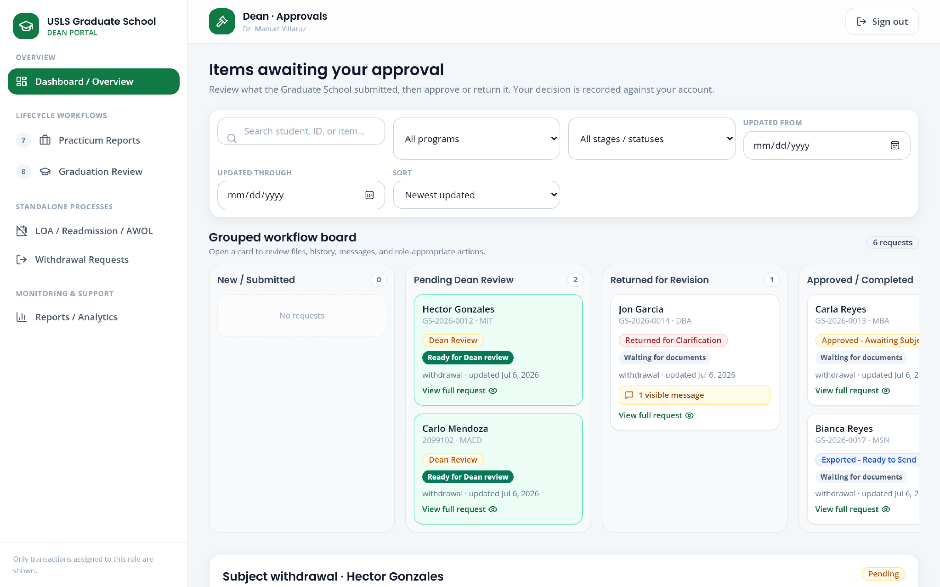

Figure U.28. Dean approvals queue (visible window; the screen continues below)

Appendix U.29. Student portal
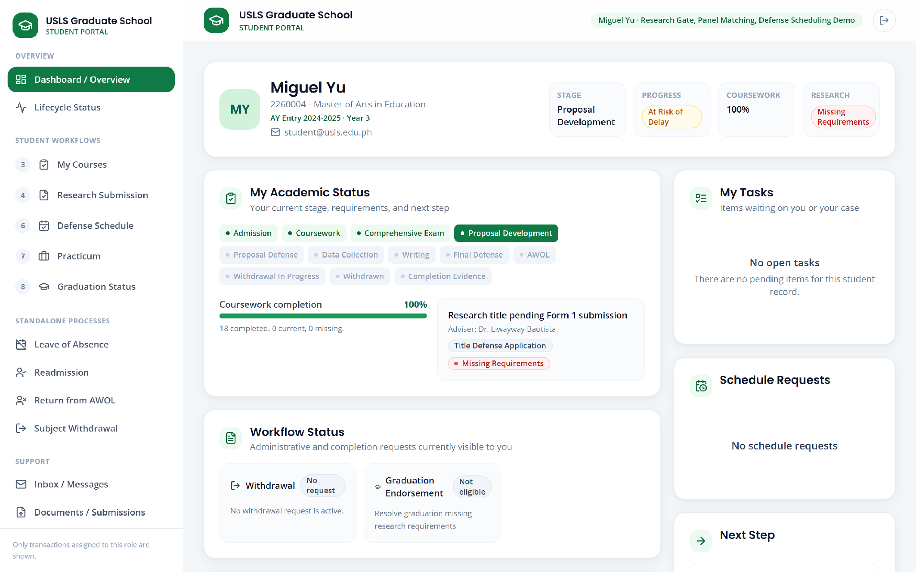

Figure U.29. Student portal (full screen)

Appendix U.30. Faculty portal
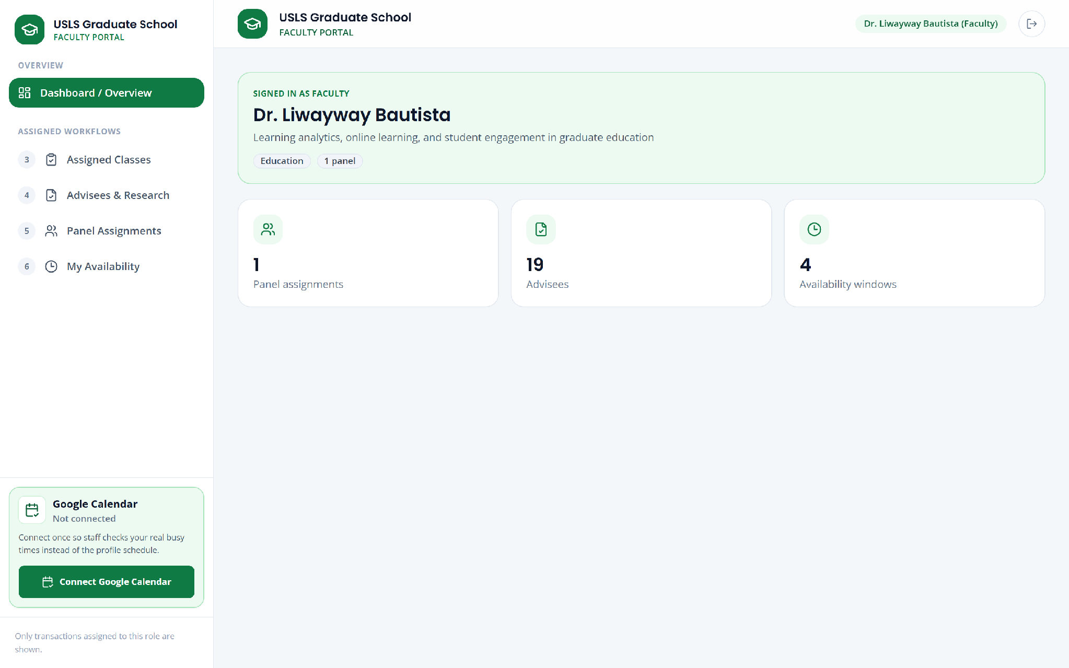

Figure U.30. Faculty portal (full screen)

Appendix U.31. Academic Coordinator view of the monitoring sheet
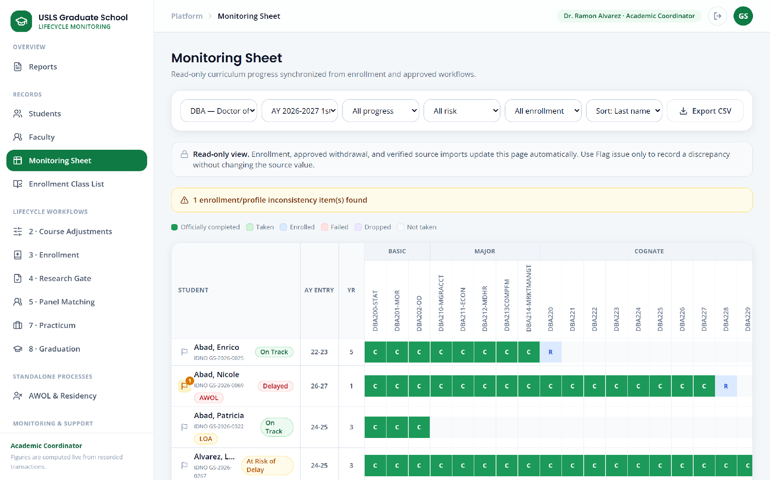

Figure U.31. Academic Coordinator view of the monitoring sheet (full screen)

Appendix U.32. Research Coordinator view of graduation
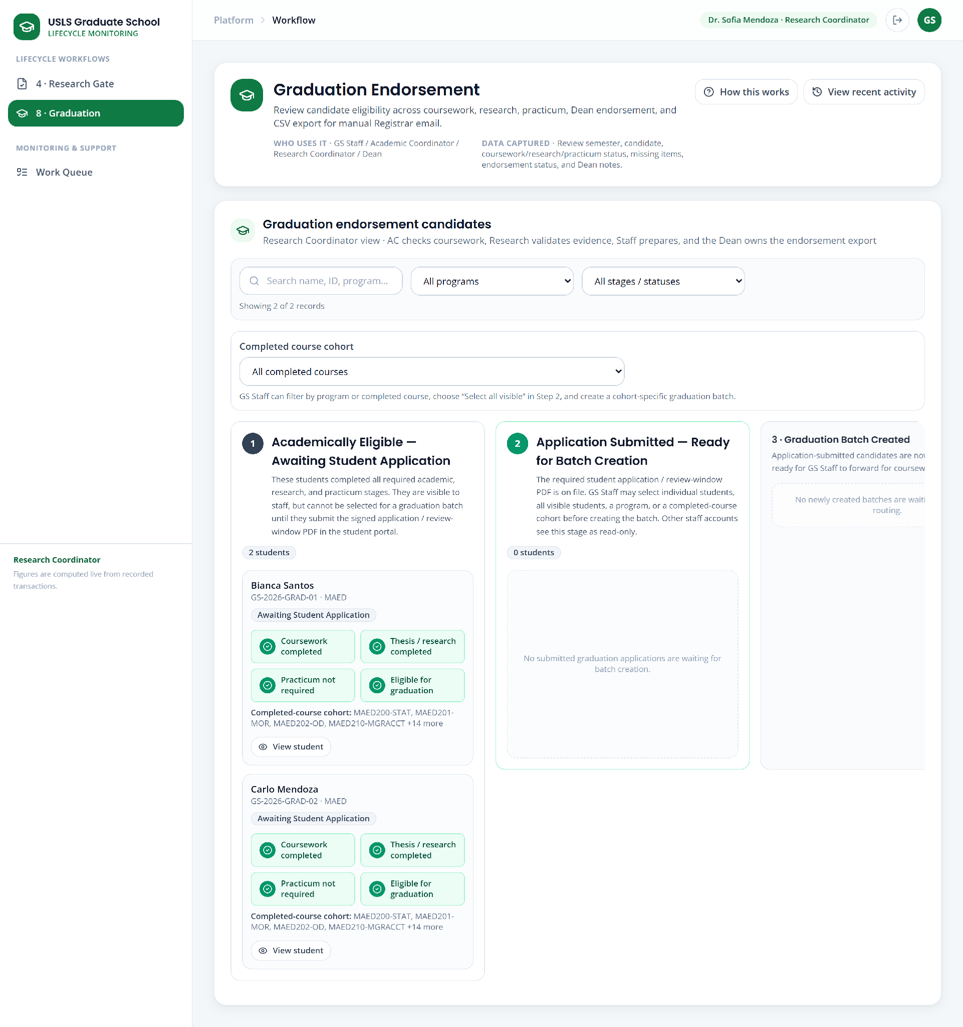

Figure U.32. Research Coordinator view of graduation (full screen)

Appendix U.33. Graduate School Staff dashboard
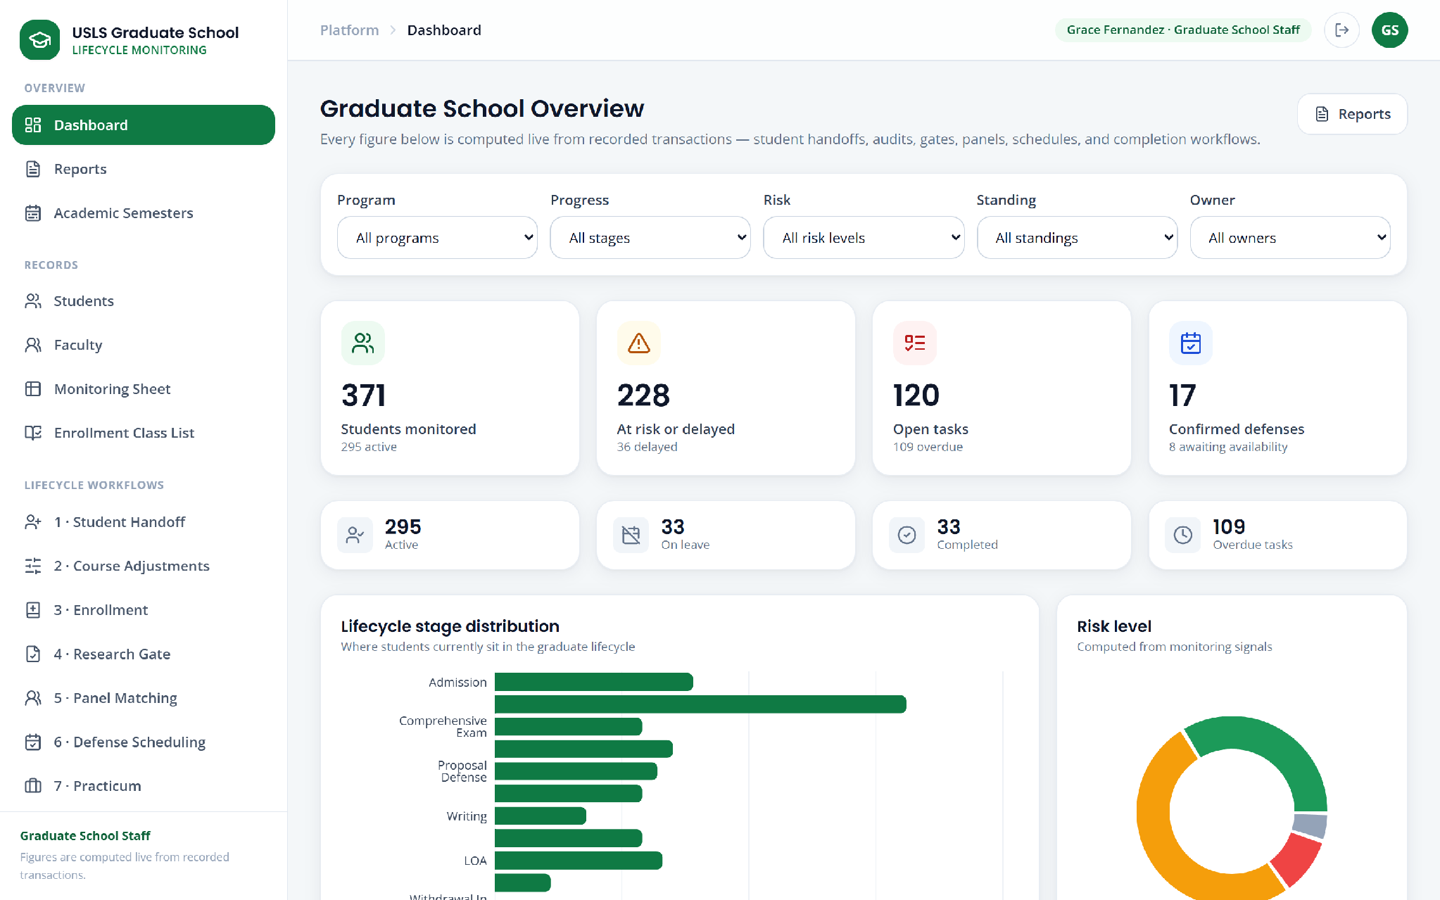

Figure U.33. Graduate School Staff dashboard (visible window; the screen continues below)

